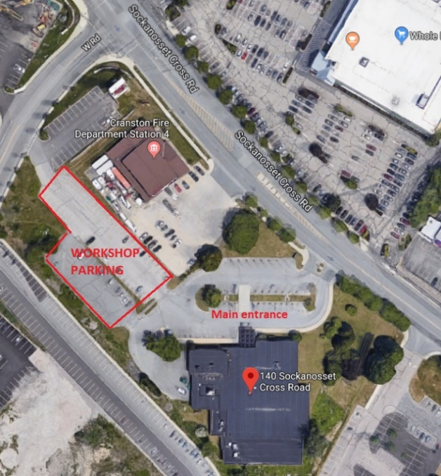
Tree Warden Workshop
Tuesday
28 Oct 2025
9:10-1:00
Large Meeting Room
Cranston Central Library
140 Sockanosset Cross Road, Cranston, RI
Park in upper lot only – SEE MAP
Library opens at 9, so don’t be too early

No-cost workshop
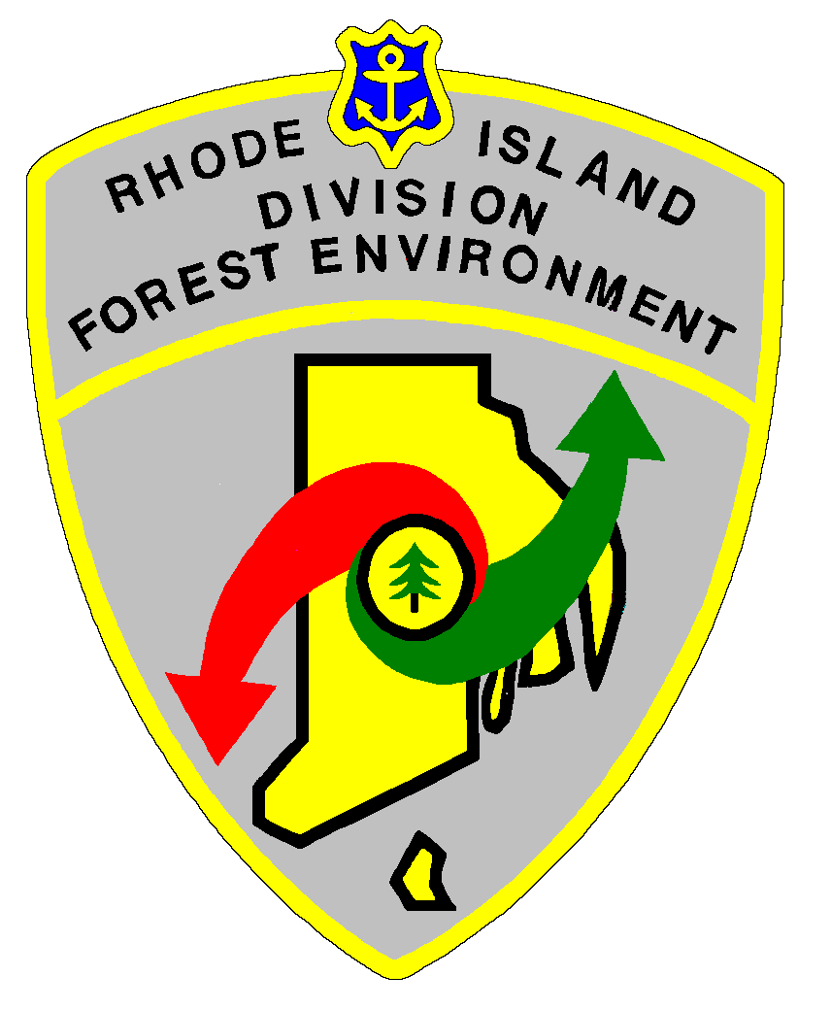
Please respond if you plan to attend
nancy.stairs@dem.ri.gov

9:10-9:20 Sign-in/registration
9:20- 9:30 Welcome and Introduction
U&CF Coordinator Lou Allard
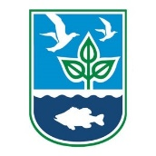
9:30-10:10 RI Energy Updates
Chris Rooney, RI Energy
10:10-10:50 Spotted Lanternfly update and other updates
Cindy Kwolek, Cooperative Agricultural Pest Survey, RIDEM Ag
10:50-11:05 BREAK
11:05-12:40 Handling Challenging Interactions
Jen West, Training & Engagement Coordinator, Narragansett Bay Research Reserve
12:40-12:50 UCF news and updates
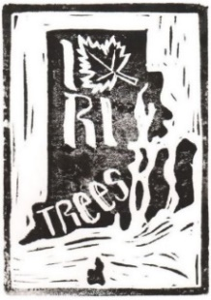
U&CF Coordinator Lou Allard
12:50-1:00 Wrap-up and feedback forms

This event is not endorsed by or affiliated with the Cranston Public Library

