Winter Moth Update
Winter moth feeding has started. Caterpillars were hatching the week of April 15th, meaning they are now visible to the naked eye. Young caterpillars feed within the leaf and flower buds and become visible as the buds expand. The preferred hosts are oaks and maples, but they will feed on other deciduous species, such as birches, beeches, apple, and blueberry.
In 2023, elevated winter moth activity was observed in several communities. This trend is expected to continue in 2024. The resurgence is occurring predominantly in areas of western Kent and Providence County, where there had been no outbreaks previously. Unlike coastal RI where releases of the fly parasite Cyzenis albicans helped reduce outbreaks, there have been no such releases in the interior locations. A program to collect C. albicans and release in these new outbreak areas is underway, with DFE, URI and UMass. It is expected to take several years to establish C. albicans in these new areas and see an impact on winter moth populations.
In the meantime, low to moderate feeding damage should recover without intervention, but trees with heavy bud feeding by small caterpillars may be considered for insecticide treatments. Treatments should be done now: after the trees have begun to leaf out, but before excessive feeding damage has occurred. Insecticides containing Bacillus thuringiensis (Btk) are also effective against winter moth at this stage. Please follow labels.

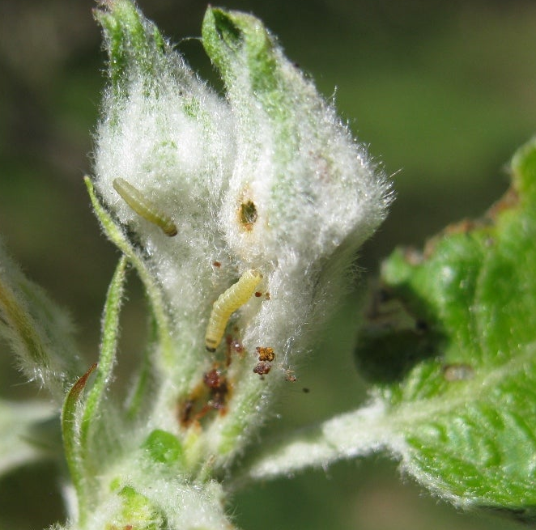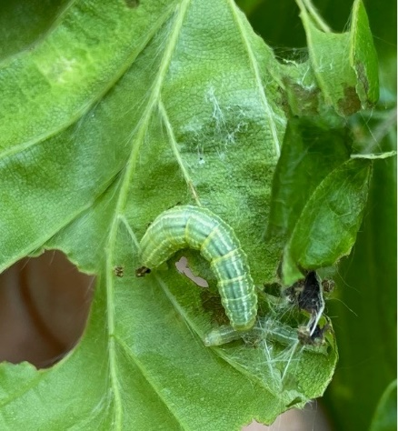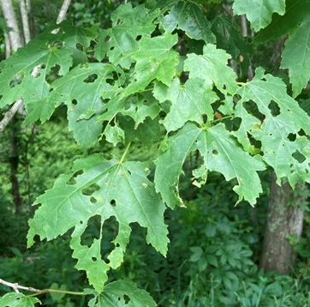
Young caterpillar and frass in an apple bud (left); later stage caterpillar (center); late-stage defoliation (right).

DEM Division of Forest Environment, Forest Health Program
Alana Russell
Alana.russell@dem.ri.gov

