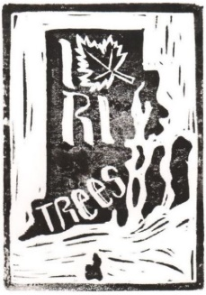
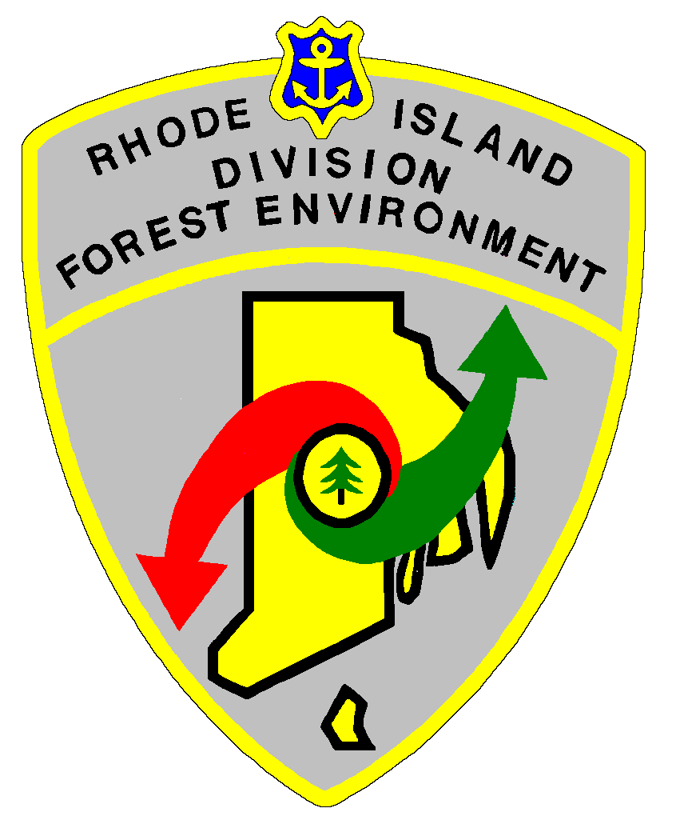
RIDEM-Division of Forest Environment
Urban & Community Forestry Program

RI Licensed Arborist Workshop
Wednesday, March 4
8:00-4:00
RI College
Faculty Center (#42), 600 Mt. Pleasant Ave., Providence, RI
(use map: www.ric.edu/documents/printable-campus-map
and bring your registered parking permit with you)

Advanced $30 Registration required:
Deadline for Registration Feb 28, 2026; lunch provided; 5.25 ISA CREDITS

8:00-8:15 Sign-in/registration
8:15 Welcome and Introduction – LOU ALLARD, DFE U&CF Coordinator
8:30-9:00 Arborist License Renewal Update and troubleshooting – BETH BANNAR, DFE U&CF Specialist
Update on new RIDEM system for renewing licenses online
9:00-10:00 Trees, Heat and Scale Insects – LOU ALLARD, DFE U&CF Coordinator
Increasing urban heat islands have an impact on pest infestations and tree health and resilience
10:00-10:15 BREAK
10:15-11:00 Permavoid Tree Rooting Systems – SAM BAUM, ABT
Tree root system installation and use in RI
11:00-12:00 Head’s Up for Tree Health – BETH BRANTLEY, Plant Pathologist, Bartlett Tree Experts
Updates and new issues lurking on our doorstep
12:00-1:00 LUNCH
1:00-2:00 RIE Utility Safety Demo – CHRIS ROONEY, Forestry Manager, RI Energy
Demo trailer
2:00-2:30 Tree Work in/near Wetlands – TBD, DEM Office of Water Resources
Tree pruning and removals in wetland jurisdictional areas – exemptions and permits on single-family residential properties or commercial properties not associated with forestry or solar
2:30-2:45 BREAK
2:45-3:45 Preparing for Storms – NANCY STAIRS, DFE Cooperative Forestry Program Supervisor
Planning and mitigation for storm events
3:45-4:00 Discussion and Feedback
Registration provided by:


