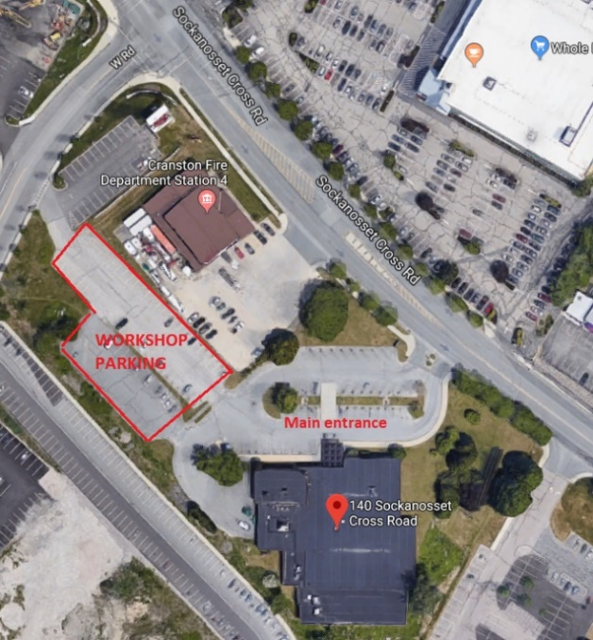
RI Licensed Arborist Workshop
Wednesday
April 8
9:30 SHARP- 4:00
Large Meeting Room
Cranston Central Library
140 Sockanosset Cross Road, Cranston, RI
Park in upper lot only – SEE MAP
Library opens at 9

Advanced $30 Registration required – limited to 50 attendees – Deadline April 3
5.25 ISA credits
9:15-9:30 Sign-in/registration
9:30 Welcome and Introduction – LOU ALLARD, DFE U&CF Coordinator
9:35-10:00 Arborist License Renewal Update and troubleshooting – BETH BANNAR, DFE U&CF Specialist
Update on new RIDEM system for renewing licenses online
10:00-10:45 Trees, Heat and Scale Insects – LOU ALLARD, DFE U&CF Coordinator
Increasing urban heat islands have an impact on pest infestations and tree health and resilience
10:45-11:00 BREAK
11:00-11:30 Permavoid Tree Rooting Systems – SAM BAUM, ABT
Tree root system installation and use in RI
11:30-12:30 Head’s Up for Tree Health – BETH BRANTLEY, Plant Pathologist, Bartlett Tree Experts
Updates and new issues lurking on our doorstep
12:30-1:15 LUNCH
1:15-2:15 RIE Utility Safety Demo – CHRIS ROONEY, Forestry Manager, RI Energy
Demo trailer
2:15-2:45 Tree Work in/near Wetlands – SAM DUFRESNE, Environmental Scientist, DEM Office of Water Resources
Tree pruning and removals in wetland jurisdictional areas – exemptions and permits on single-family residential properties or commercial properties not associated with forestry or solar
2:45-3:00 BREAK
3:00-3:45 Preparing for Storms – NANCY STAIRS, DFE Cooperative Forestry Program Supervisor
Planning and mitigation for storm events
3:45-4:00 Discussion and Feedback

This event is not endorsed by or affiliated with the Cranston Public Library

