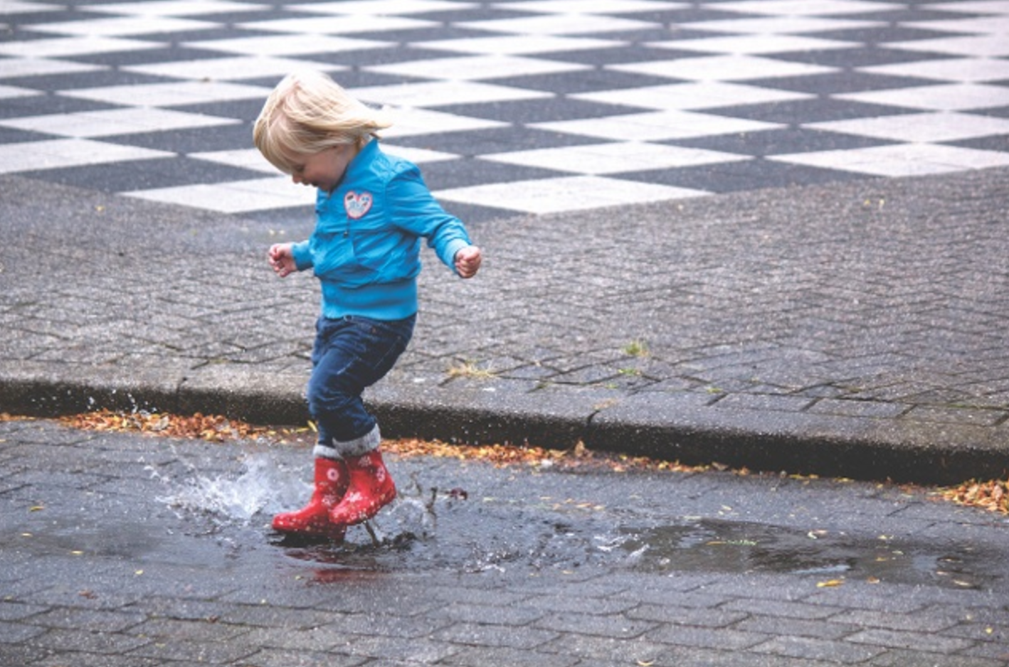

PRESENTED BY THE EASTERN RI CONSERVATION DISTRICT
Sponsored by The Newport Arboretum
RSVP schurgin.ericd@gmail.com/401-934-0842

EFFECTS OF STORMWATER IN RESIDENTIAL NEIGHBORHOODS
300 Spring Street

  - Many of us have fond childhood memories of puddle-stomping or dancing in the rain. But as we get older, we lose that wistful sense of enjoyment. Instead, rain is often considered a nuisance and a source of discomfort whether we find ourselves commuting to work or forgetting our umbrellas at home. However, we rarely think about the logistics of rainstorms. Where does all that water go? What happens to the rain that hits a parking lot, a roof, or some other man-made structure? Stormwater is where things start getting dicey!

February 22, 2017 5:30
Newport Public Library

