NARRAGANSETT BAY COMMISSION
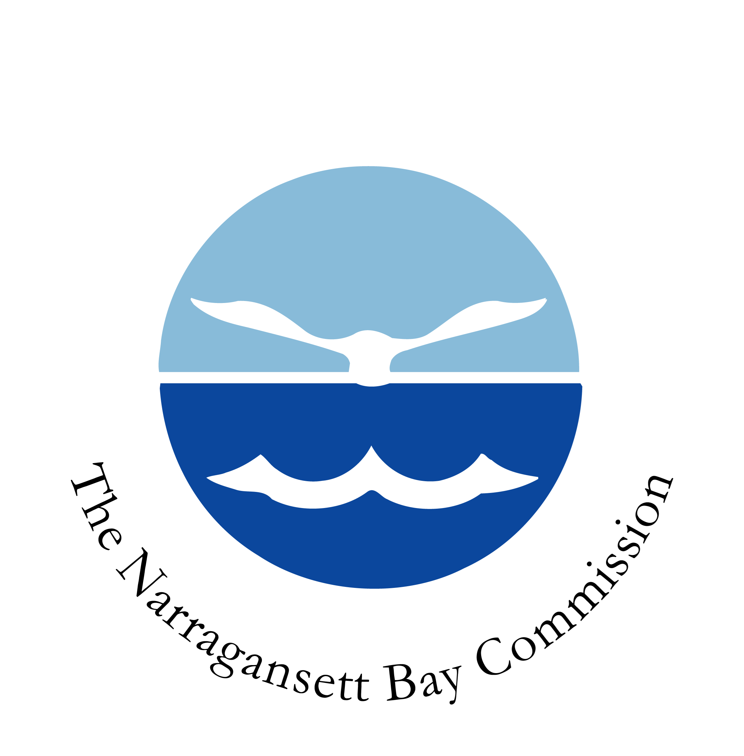

VACANCY NOTICE
Phone: 401-461-8848 ext 371 HR Clerk
Title and Number of Position: | Maintenance Supervisor FP013
Application Period: | 10/1/2024 – 10/8/2024
Salary Range: | Grade 6A / $53,888.00 - $88,915.00
Division – Section – Unit: | Operations & Maintenance / Fields Point
Shift and Days: | 7:00 AM – 3:00 PM Monday - Friday
Location: | Providence
Position Covered by Bargaining Unit Agreement: | No
DUTIES/RESPONSIBILITIES: Oversees the day-to-day work of the maintenance crew. Primarily responsible for supervising all preventative and corrective maintenance activities on all mechanical, electrical and instrumentation equipment at the wastewater treatment facility and remote pumping stations. Partners with operations management to ensure equipment and materials are available and functioning properly. Provides back-up support for the Maintenance Manager on scheduling and staff management duties. Provides input on the purchasing of equipment and parts through the capital planning budget preparation process. Assigns, directs, and trains employees in the Maintenance Section. Sets priorities, renders technical advice, and provides supervision in the field. Interprets policy and resolves issues/problems (personnel, union grievances, safety, maintenance questions, etc.). Ensures all work is performed in accordance with NBC policy guidelines, maintenance SOP’s, state and federal permit requirements and union collective bargaining agreement. Prepares daily reports (verbal and/or written) on work completed, work order status, employee supervision and training. Maintains all tools all tools inventory, repairs and replaces tools as needed. Continually inspects facility equipment, structures and buildings and creates service requests/work orders for needed repairs. Research information on supplies, tools and equipment needed for maintenance and operations and places orders as needed. Coordinates with the development of all job safety analysis documents, standard operating procedures, and other safety material. Maintains logs/records of all field activities performed by the maintenance team. Complies with and enforces all applicable NBC/OSHA safety guidelines including Lock out / Tag out; confined space entry; hazardous waste handling; use of personal protective equipment, Right-to-Know requirements, etc. Oversees the maintenance and operations for NBC’s vehicle fleet. Assists with determining whether maintenance should be performed in-house or contracted out to a third party. Supports vendor management and procurement activities by shopping the market for parts and equipment to ensure that the most competitive pricing is secured for NBC. Participates in planning efforts for capital equipment purchases in partnership with the asset management function. Schedules field support maintenance for all installation and repairs for field infrastructure. Receives assessments from crew members and prioritizes the repair and/or replacement of capital equipment accordingly. Uses Hansen CMMS to input and extract work orders, equipment data, repair history, etc. Performs other related duties as assigned within skill and experience capabilities.
EDUCATION/EXPERIENCE/SPECIAL REQUIREMENTS:
EDUCATION/EXPERIENCE: Graduation from a four-year degree program or an equivalency vocational program plus at least eight years of experience in a wastewater treatment facility maintenance department as a mechanic or other tradesperson is required. A minimum of 3 years supervisory experience is required.
KNOWLEDGE, SKILLSAND ABILITIES: The ability to plan and assign duties to subordinates, possess good verbal and written communication skills; the ability to understand and apply proper maintenance techniques; the ability to lead a workforce of skilled craftsmen. SPECIAL REQUIREMENTS: Possession of a Grade I Wastewater Treatment Operators license and valid driver’s license.
AMERICANS WITH DISABILITIES ACT (ADA) PROVISIONS:
REASONABLE ACCOMODATION: If an applicant is unable to perform any essential job functions because of their disability but can achieve the required results by means of a REASONABLE ACCOMODATION, then the individual shall not be considered unqualified for the position. MEDICAL INFORMATION: Successful completion of a pre-placement physical examination and drug screen will be required after a conditional offer of employment has been made.
TO APPLY:
Apply within the application period as shown on notice. This Agency does not assume responsibility for applications sent through the mail. NOTE: The Narragansett Bay Commission union contracts allow a 3-day grace period for its members only.
APPLY ONLINE OR SEND RESUMES TO: resumes@narrabay.com (resumes must be in Word or PDF format), deliver to One Service Road, Providence, RI 02905 attention Human Resources, or Fax to 401-461-2242.

THE NARRAGANSETT BAY COMMISSION IS AN EQUAL OPPORTUNITY EMPLOYER

