NARRAGANSETT BAY COMMISSION
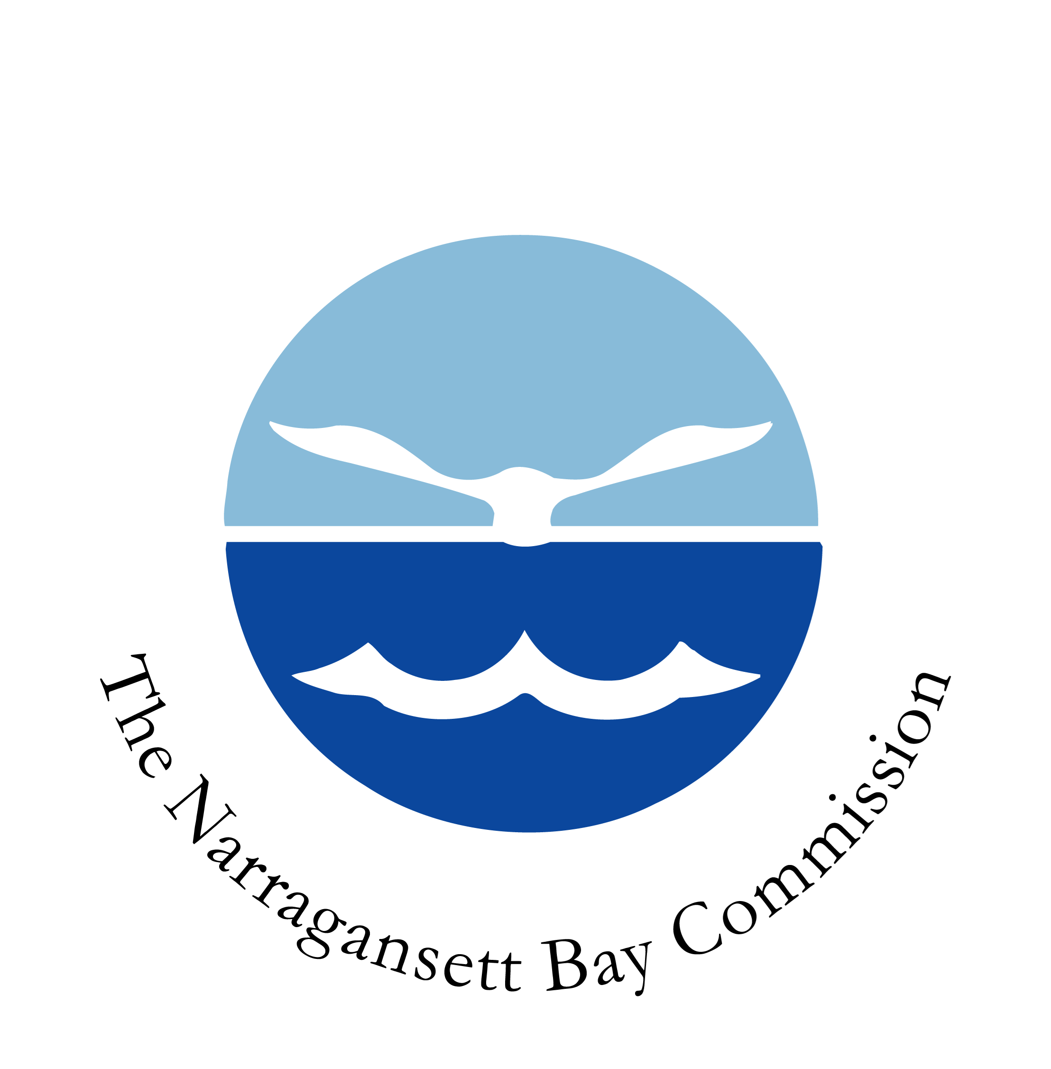

VACANCY NOTICE
Phone: 401-461-8848 ext 371 HR Clerk
Title and Number of Position: | Mechanic I – FP056
Application Period: | 10/24/2024 – 10/31/2024
Salary Range: | Grade U5 $25.93 - $32.93 Starting Salary $25.93
Division – Section – Unit: | Operations & Maintenance / Fields Point
Shift and Days: | 7:00 AM – 3:00 PM Monday - Friday
Location: | Providence
Restrictions: | None
Position Covered by Bargaining Unit Agreement: | Yes
Name of Bargaining Unit | Laborers’ International Local 1033

DUTIES/RESPONSIBILITIES:
Responsible for performing a variety of preventative and general maintenance and repair on plant and facility equipment and machines. Installs, maintains, and repairs machines and equipment in plants and related facilities. Performs a variety of preventative maintenance on pumps, motors, hydraulic systems, and related plant and facility equipment within plant property and at remote facilities and locations. Performs a variety of maintenance requiring knowledge of plumbing, pipefitting, electronics, welding, small-engine repair, and other skilled trades. Operates a variety of tools and equipment in the maintenance and repair of machines and equipment. Completes work orders and paperwork regarding daily maintenance and repair duties. Assists with inspecting the plant and related facilities for mechanical and equipment problems. Works with other plant and NBC staff in the maintaining and repair of plant and facility equipment, such as operators, electricians, process monitors, instrumentation technicians, and others as appropriate. Performs other duties of a similar nature or level.
EDUCATION/EXPERIENCE/SPECIAL REQUIREMENTS:
EDUCATION/EXPERIECE: High School Diploma, or G.E.D., and One year of general maintenance experience; OR: an equivalent combination of education and experience sufficient to successfully perform the essential duties of the job such as those listed above.
SPECIAL REQUIREMENTS: Must possess valid driver’s license in good standing. Grade I Wastewater Operator License is required within one year of employment.
AMERICANS WITH DISABILITIES ACT (ADA) PROVISIONS:
REASONABLE ACCOMODATION: If an applicant is unable to perform any essential job functions because of their disability but can achieve the required results by means of a REASONABLE ACCOMODATION, then the individual shall not be considered unqualified for the position. MEDICAL INFORMATION: Successful completion of a pre-placement physical examination and drug screen will be required after a conditional offer of employment has been made.
TO APPLY:
Apply within the application period as shown on notice. This Agency does not assume responsibility for applications sent through the mail. NOTE: The Narragansett Bay Commission union contracts allow a 3-day grace period for its members only.
APPLY ONLINE OR SEND RESUMES TO: resumes@narrabay.com (resumes must be in Word or PDF format), deliver to One Service Road, Providence, RI 02905 attention Human Resources, or Fax to 401-461-2242.

THE NARRAGANSETT BAY COMMISSION IS AN EQUAL OPPORTUNITY EMPLOYER

